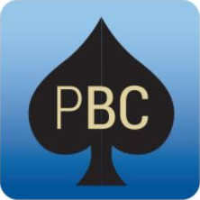
PENINSULA
BRIDGE CLUB INC
Course Outline October 2018

Aim: To introduce the basic mechanics of the game of Bridge
How: Learning the basics of Bridge through playing hands

LESSON OUTLINES Dates

1. The mechanics of Bridge 8 October
2. Introduction to bidding 15 October
3. Bidding and responding to 1NT 22 October
4. Responding to Level 1 opening bids 29 October
5. Opener’s second bid 5 November
6. Responder’s second bid 12 November
7. Practice play 19 November

The course will also introduce the playing strategies of trick promotion, the finesse, trumping losers, discarding losers and what card to lead.

Each lesson is supported by material in the text Play Bridge by Joan Butts

October Course: 8 October - 19 November 2018
Start Date: Monday evening 8 October, 7pm-9pm

Cost: $100 includes text book & weekly email lesson summaries. No partner required. Players repeating the course $10 per lesson

Pre-register: email: Susan Jensen: soxfeldt1@gmail.com
mob: 0405061252
If you would like to register for this course please make your preregistration payment to Susan Jensen who will be running the course.

Payment details:
Direct debit to St George Bank
BSB: 112-879
A/c no: 109 122 562

Please write your surname and Bridge Ed to describe your payment.

